1. **Install Python software**

To install Python on a Windows-based computer, you can follow these general steps.

**Download Python**: Visit the official Python website at https://www.python.org/downloads/windows/ and download the latest Python installer for Windows. Choose the version that matches your system (e.g., 32-bit or 64-bit).

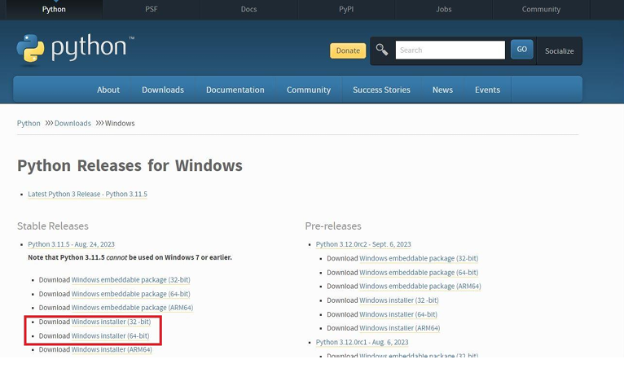

**Run the Installer**: Double-click the downloaded installer (e.g., python-3.x.x.exe) to run it. Make sure to check the box that says "Add Python X.X to PATH" during installation. This option is essential for using Python from the command line.

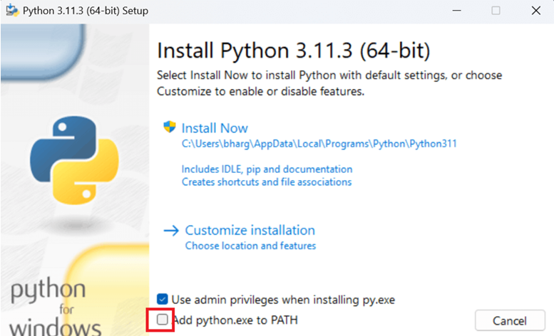

**Install Python**: Click "Install Now" to start the installation process. Python will be installed on your system.

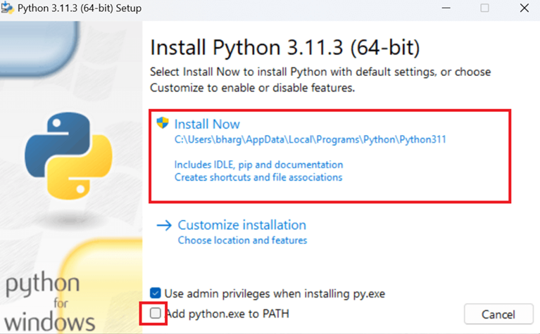

**Verify**: To verify that Python was installed correctly, open the Command Prompt (search for "cmd" in the Windows Start menu), and type python--version. You should see the installed Python version displayed.

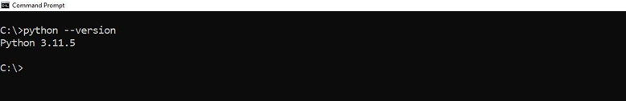

1. **Demonstrate about Basics of Python Programming:**

* **Print HelloWorld:**

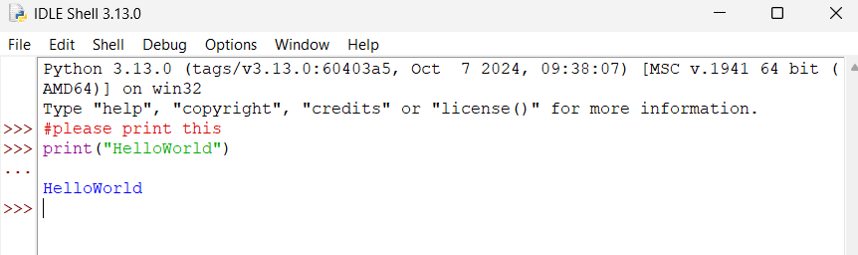

* **Describe Local Variable and Global Variable with Code**

**Code:**

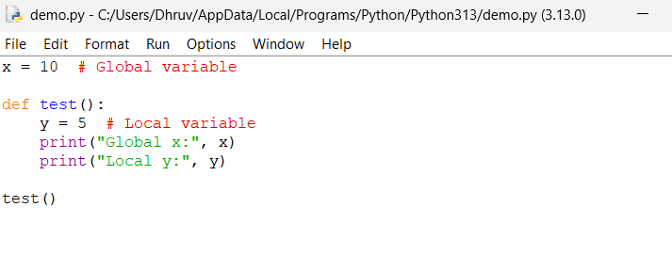

**Output:**

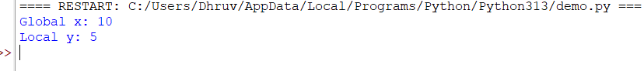

* **Write a code that describe Indentation error**

**Incorrect code (causes IndentationError):**

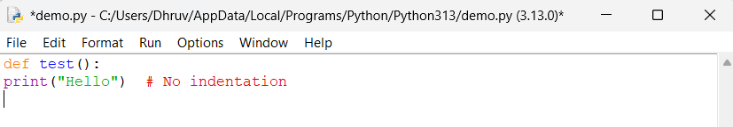

**Correct code:**

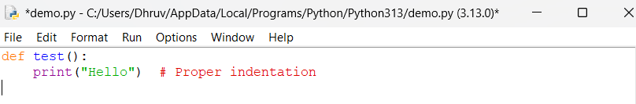

* **Write a code that describe local and global variable with same name follows the roles**

**Code:**

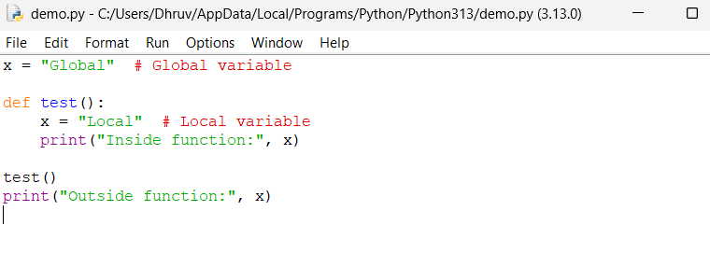

**Output:**

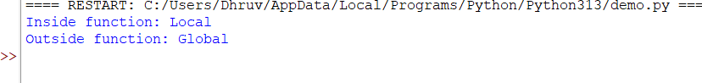

* **Write a code for string, int and float input.**

**Code:**

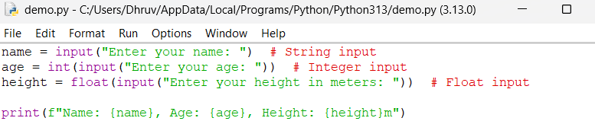

**Output:**

